Kaipara Hunt Spring Newsletter October 2015 | 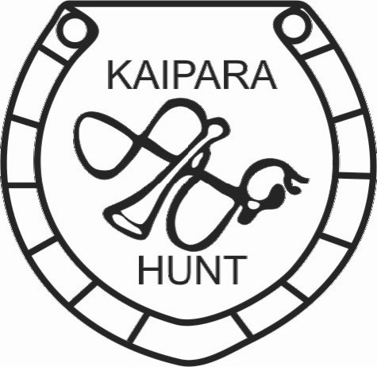
Deputy Master: Janine Hames 094317059  Secretary/Treasurer: Albert Doornenbal 094312059/ 021 956032  Huntsman Daf Davies 027-2277052 /09 2809509 | kaiparahunt@xtra.co.nz  www.kaiparahuntinc.yolasite.com  Master: Val Nelson 09 4322133 /021433159  President:  Bruce Wakeling 094312940 / 0274744175

At last the warmer drier weather is here time to think about ending the horses holiday and doing some riding again.

Kennel Report. Fibi and Hooters pups are now 4 months old, (Manfred, Missy, Nero, Nibble) they are growing fast and are up to all sorts of mischief. These are 4 new entrants to watch out for next season.
Sunday Rides: The venues are all set for our ever popular Sunday rides, bring your friends and family this is a very low key outing, great for green horses and nervous nellies, also a lot of fun and very social. First ride will be on 18th October, Dempster property, 124 Paparoa Station Road, Paparoa. Full list of where and when the rides are planned is on our website.
Show Jumping Evenings: at Maungaturoto Rec farm will be under way again soon on Wednesday evenings. $10 per horse all abilities and heights catered for.
Kaipara Hunt AGM: Friday November 13th 8pm at Maungaturoto Country Club, This is an election year which means that all position are up for election, new committee members are more than welcome please don’t be shy in putting your name forward. We are always looking for new ideas and feedback. Dinner will be available beforehand for those who wish. Please bring a plate for a shared supper.
The whole present Committee, Officers and Committee members, apart from Margie Hannon, have indicated that they are available for re-election.
All written nomination must be with the secretary by the 3th November

It’s with deep regret we learned about the passing of Patience Izard who has long since been a keen supporter of all horse sports. Our condolences to Pip and family.

