Kaipara Hunt Newsletter  January 2015 | 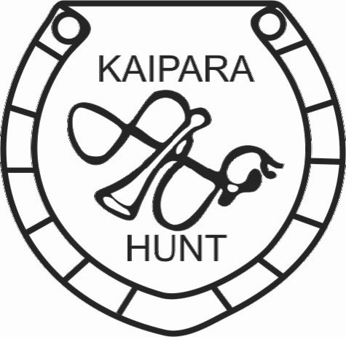
Farmlands Wellsford Supports  Kaipara Hunt | kaiparahunt@xtra.co.nz  Bruce Wakeling 094312940 / 0274744175  Garry Pocklington 0274068127

Merry Christmas and Happy New year to all Kaipara Hunt Members
Thank you! aHUGE thank you to everyone who worked so hard in the heat at Woodhillsands last weekend. What a great team we all make.
SHOWJUMPING: Tuesday( note day change) nights from 4pm $10 per horse, come and join us for a fun evening all heights and abilities catered for.
Trek: Kaipara Hunt Annual Bonanza Trek 23rd – 25th January. Please remember this is one of our annual fund raisers so please support where you can.
Day Trek: Marohemo14th February 10,30am McKay and adjoining properties. Mark this date on your calendar , please support this fun trek and help Sam achieve her goal of reaching Base Camp.
Kumeu Show Fundraiser 14th -15th March. Please keep this weekend free, all help very much appreciated. Contact Inga if you are available to help, even one day would be great.
Hounds Gary is underway with the hound’s fitness program. We have 3 lovely puppies at the kennels all needing names starting with M.
Hunt Card this is well in the planning stages, and subs can be paid to Albert any time from now on. Renewal form is attached and on hunt website. Opening Hunt Sunday 5th April.
Speedy recovery to Jo Hall after her accident last Monday Night.

